Deliverable 7.1
Basic set of control and monitoring primitives for the WP4-demonstrator array
Jussi Markkanen
12-March-2009
Figure 1 shows the demonstrator arrow as perceived by the user-level control and monitoring software (EROS). The antenna array consists of three sub-arrays, SbA 1-3. Each sub-array provides eight signals to the receiver front-end block FE 1-3. In a front-end block, each signal line is subjected to signal-level attenuator (A), low-noise amplifier (LNA) and A/D converters, followed by a digital downconverter (DDC). The digital downconverter comprises of two parts: a numerically control oscillator (NCO) and a cascade of filters and decimators (FIR). After manipulations in the front-end, the signals from the sub-arrays are send over (non-programmable) communication link to a beam-former block (BF), and after that, to a general-purpose workstation for further processing and storage. EROS provides basic primitives to setup and start and stop these various sub-blocks, as well as limited means of showing status information. In most cases, the setup only means uploading a file (or rather, data based on a file) to the block. Here we follow the established practice of EROS design that the contents of those files is somewhat external to EROS, in the sense that the contents of the files are generated by external programs, but the EROS uploading routines are able, to smaller or larger degree, check the validity of the file contents before uploading.

The front-end block is handled by two user-level commands, rack and ddc, each of which has several subcommands, some doing control tasks, some serving for monitoring. In addition of the user-level commands proper, EROS customary provides also an unprotected wrappers around whatever low-level commands the hardware developers may have been using for accessing the hardware, so that these engineering commands can also used directly from within EROS.

- rack stop subarray - stops all the 8 ADCs of the specified sub-array
- rack start subarray - starts all the 8 ADCs of the sub-array, and does various other initializations
- rack reset subarray - opens the receiver by resetting the protection attenuators
- rack print subarray - display various information about the front-end state, including the state of the attenuators and values of several temperature sensors.

- ddc setfrequency subarray value - set the NCO frequency on the DDC
- ddc loadfilter subarray filename - setup the decimators and filters on the DDC
The beam-former block is handled just by loading a configuration file

- beamformer load filename

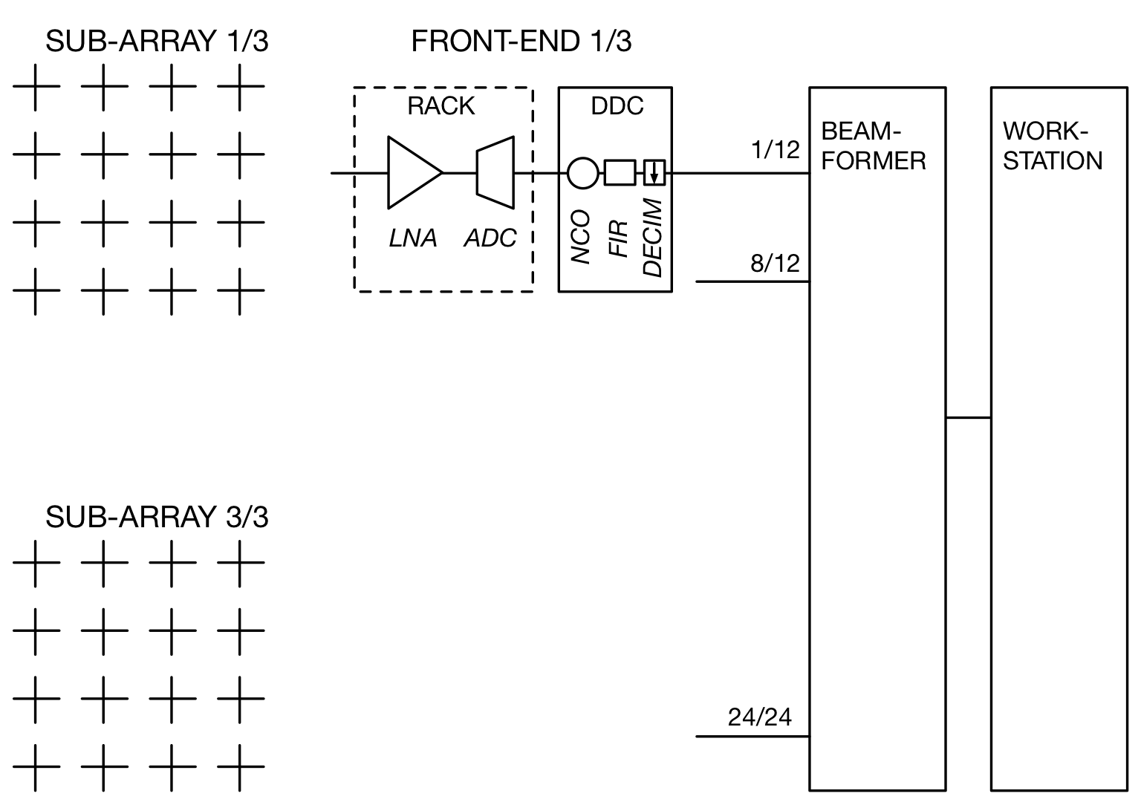
Figure 1. EROS view of the demonstrator array.

